9 October 2025

Mr. Naulu Mataitini

Dear Sir,

RE: CEASE AND DESIST - DEMAND

- We act for Pacific Polytech (“our client”).

- We have been advised by our client that you have caused to be published a social media post entitled “The Selective Microscope: Why is a Tertiary Scandal Worth a COI, but a $360M Cyclone Scandal is Not?” containing defamatory statements against our client.

- The post includes allegations suggesting that grants to Pacific Polytech were given to an “unaccredited” institution and implying improper or illegal conduct.

- We have been provided with evidence of these materials, which are widely circulated and read in Fiji.

- The statements in your post are false, malicious, and defamatory, particularly the suggestion that Pacific Polytech is “unaccredited”.

- The Screenshot of the same is as follows:

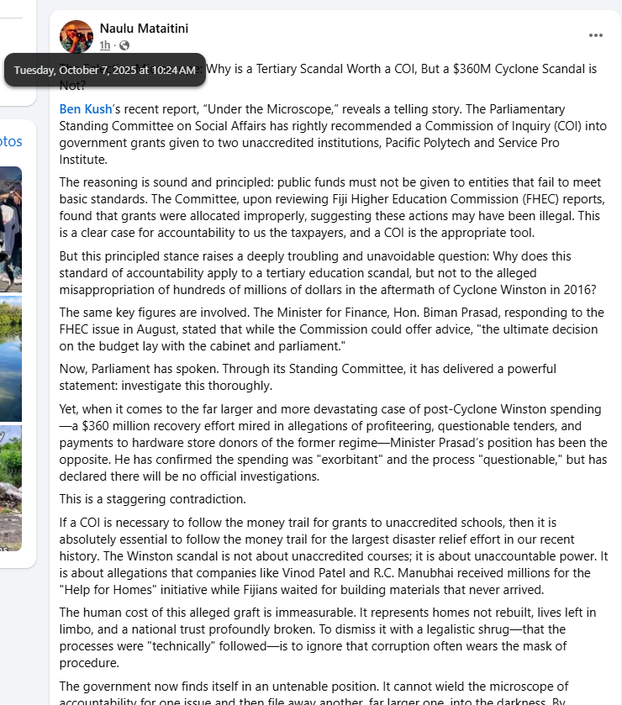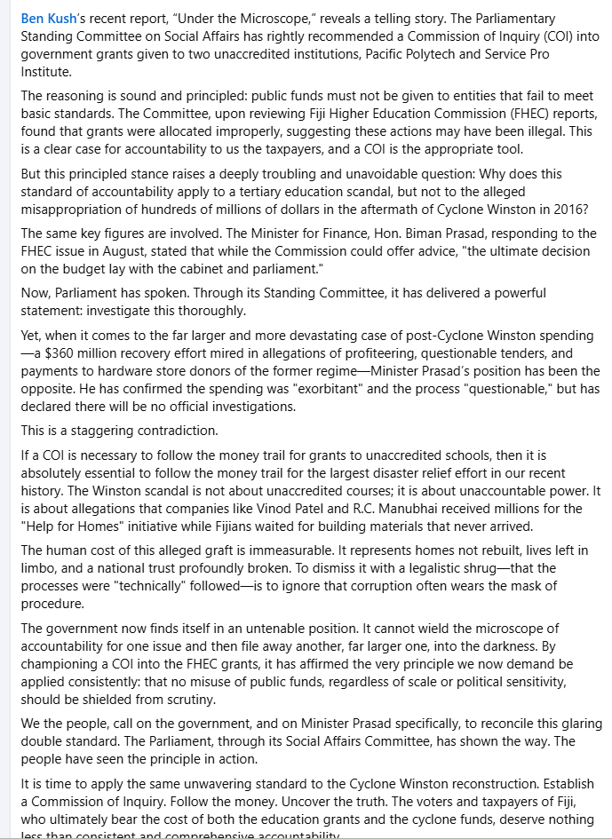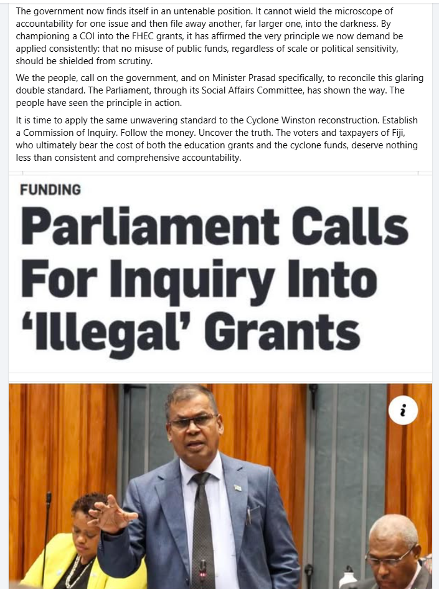

- The posting and comments are publicly accessible on social media and have been viewed by many residents of Fiji. The statements have been made without any proof or evidence.

- You are hereby directed to Cease and Desist further publication of any defamatory and malicious materials, posts or comments of our Client’s reputation.

- Our client is a recognised educational entity by the government of Fiji and they are governed by and under the laws of Fiji where procedural and regulatory frameworks are established to be followed.

- The posting on Facebook by you has disparaged, tarnished and damaged our client’s reputation, character and standing in the educational, social and business communities and organizations.

- TAKE NOTICE that via this letter we on behalf of our client instruct and demand from you to immediately carry out the following:
- Cease and Desist all publication of any defamatory and malicious posts against Pacific Polytech;
- Remove forthwith all posts and comments against Pacific Polytech from social media;
- Publish a public apology in the same forum, clearly stating that Pacific Polytech is accredited and that all allegations to the contrary are false;
- Cease and desist from any future publication of defamatory or malicious material concerning Pacific Polytech;
- Pay FJD $500 legal cost incurred by Pacific Polytech in issuing this notice;
- Provide proof of removal of the posts, publication of your apology, and payment of the sums demanded within 7 days of receipt of this letter.

- Should you fail to comply with the above, we hold firm instructions to institute LEGAL ACTION AGAINST YOU WITHOUT ANY FURTHER WARNINGS and in which case you will be penalized.

- We will use this letter as further evidence in Court seeking damages against you.

Yours faithfully,
KARUNARATNE LAWYERS

……………………………………

